**Individual Contribution**

My contribution towards the Group Project on the NYC 2015 Street Tree Census Data set is to determine that every Tree is a single Data point and each Tree is necessary to play a vital role for Dashboarding and Analysis. I have built an Interactive Dashboard using Tableau and R Shiny. I also organized meetings with the peers/ teammates to get on track with project, analysis, and discussions. We all started trying to find dataset attributes. during this my role as been led to selecting the dataset after thorough research and discussions with the peer. I also used my understandings of the dataset in R Shiny and Tableau.

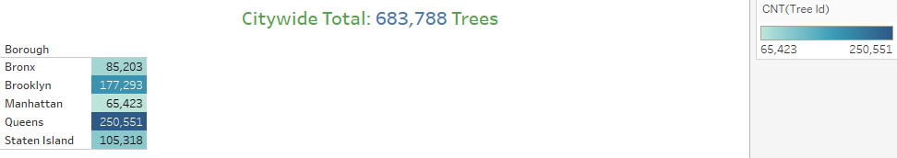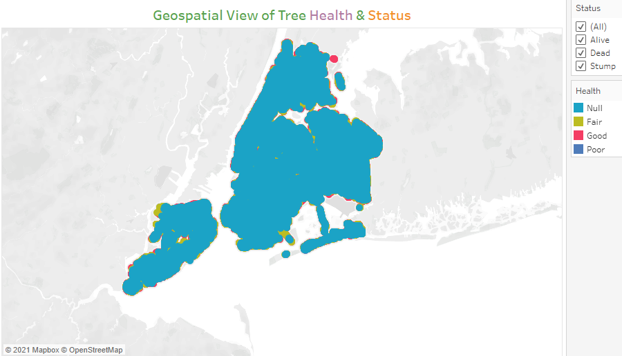

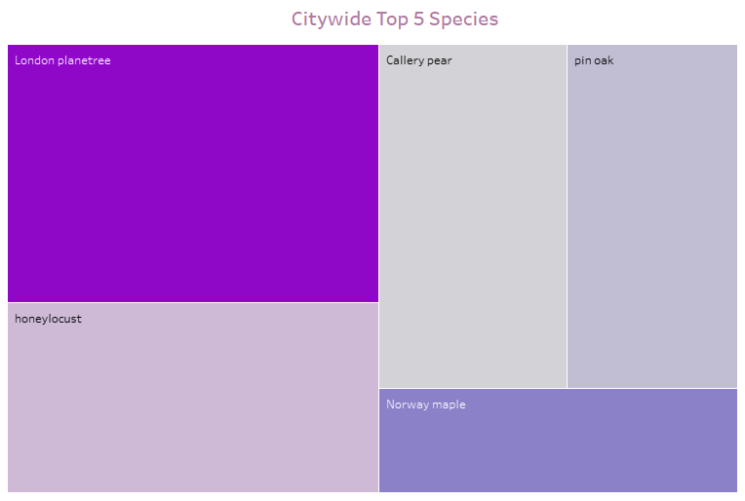

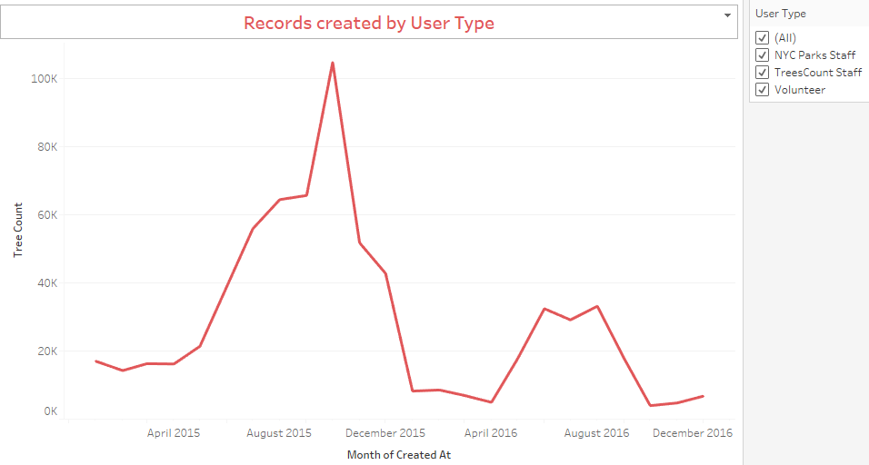

In this project Trees have problems due to Root Stone which will make Tree core weak and causes several issues. I also further helped my peers with an understanding of the project, dataset, and R programming. I took it as a chance to explore the dataset and develop dashboards in an exceedingly better way. This helps the stakeholders to form and make data-driven decisions and implement key strategies to concentrate on Greenery within the NYC

**My R Shiny Dashboard**

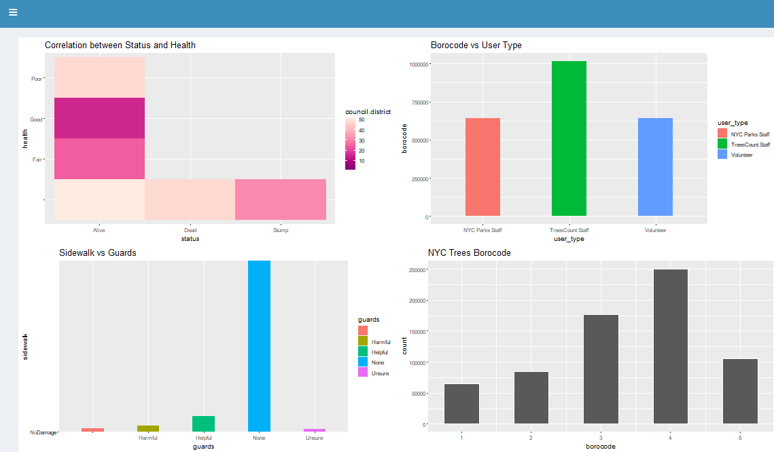

**My Tableau Dashboard**

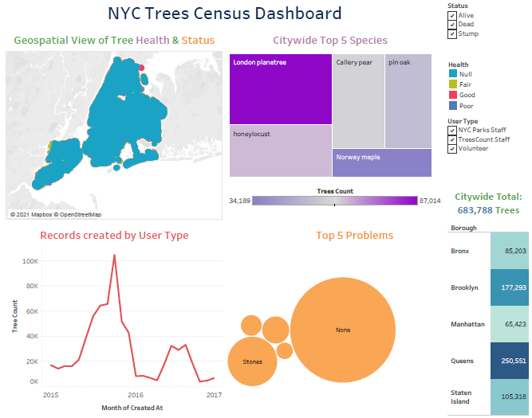

My recommendations to the City stakeholders is to Increase the Water and Pesticides resources for Saplings and small plants. Utmost care needs to be taken for Manhattan and provide with right staff for improvements Health checkup and proper care should be implemented. NYC must allocate necessary funds and raise money from the NGO’s, Volunteers, and Organizations. The City representatives must take necessary precautions by implementing proper policies and procedures. Increase the number of Green Initiative Campaigns throughout the city. Remove unwanted trees and support for continuous maintenance.